**Depth Mechanic:** Plays sound file and shakes screen heavily

**Azar, The Gatekeeper✅**

* Boulders move faster and about 25% more accurately.
* His rock wave doesn't have any open spots in it.

**Weapon:** Azar’s Will

**Type**: Machine Gun

**Bullet Type:** Explosive

**Magazine size:** Really Large (60)

**Damage:** Moderate

**Rate of Fire:** Slower

**Reload:** Desperately Slow

**Effect:** Shoots a crystal that when it hits, explodes dealing damage. Plays unique crystal sound

**Depth Mechanic:** Plays sound file and shakes screen heavily

**Dym, The Living Shadow✅**

* Smaller cloud projectiles with double the amount.
* 25% Faster attacks
* New Attack(Replaces Grab): Minion Cannon: Fires one minion at a time with deadly accuracy towards the player. Fires three for the attack duration.
* Phase 2: Boss is faster and chases the player more. Trying to make his AoE more of a threat. Cloud port is more often
* Boss room changes: Make it a big circle

**Weapon:** Hands of Dym

**Type**: SMG

**Bullet Type:** Scatter

**Magazine size:** Medium (30)

**Damage:** Low

**Rate of Fire:** Fast

**Reload:** Fast

**Effect:** Bits of shadow.

**Thwandar The Huntress✅**

* Has an Heavy rifle for phase 1, fires 5 bullets then moves.
* Launches a mine (Explosive, stasis, poison) before every movement
* Spawns a turret every second move(Spawns in 1 of 4 spots, spawns it then launches mine)
* Phase 2: switches to a sniper rifle and fires 3 very accurate shots then moves. (Almost unfair in accuracy)

**Weapon:** The Eye of Thwandar

**Type**: Sniper

**Bullet Type:** Plasma

**Magazine size:** Very Low (3)

**Damage:** VERY HIGH

**Rate of Fire:** VERYFast

**Reload:** Medium

**Effect:** Special Sound effect.

**Shuude M’ell, Voice of the Deep**

* **✅**Change to Attack: Basic attack: Now has a wider range of bullets(90 degrees in a cone in front)Not cascading.
* 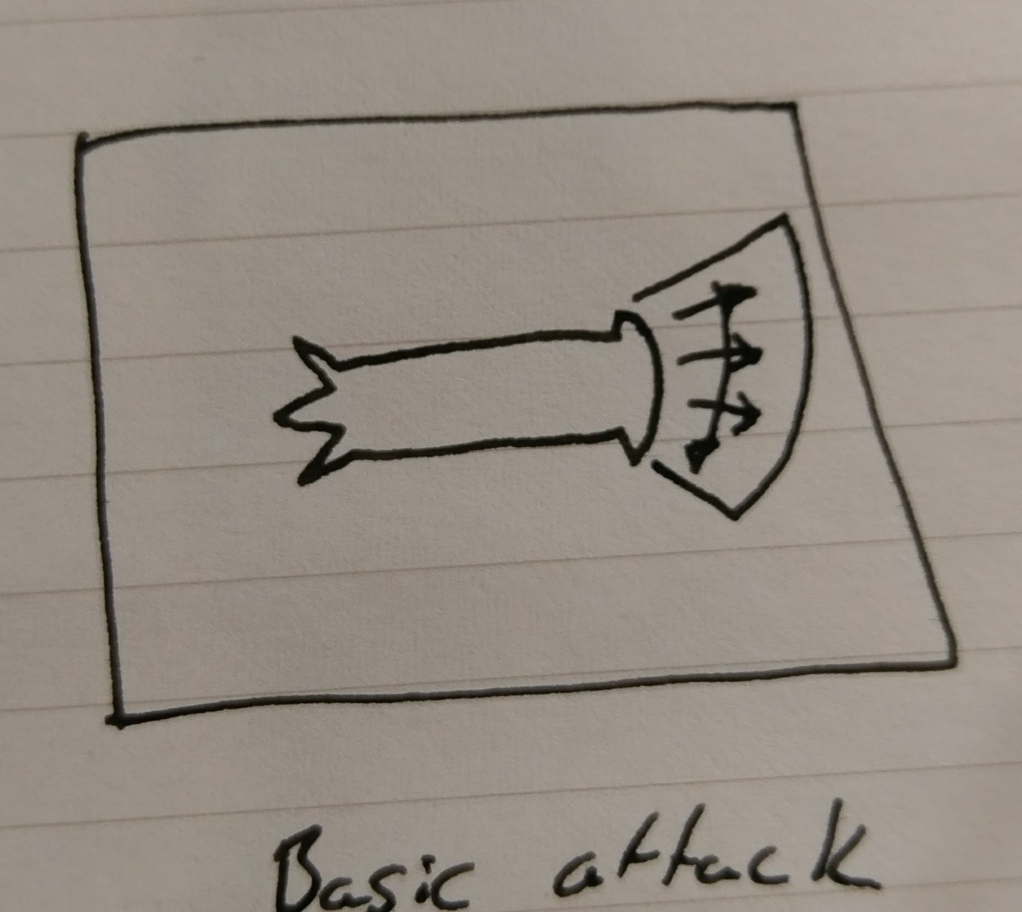
* **✅**Change to Attack: Rush attack: The attack needs more predictability. Same attack, with an initial pause before it of 0.5s
* **✅**Change to Attack: Scream Beam: The attack lasts a second longer. Slows ore before using it
* New attack: Echolocate: Fires a cascading wave of bullets in a 270 degree radius from left to right (or right to left doesn’t matter.) slows down 2s before casting.
* 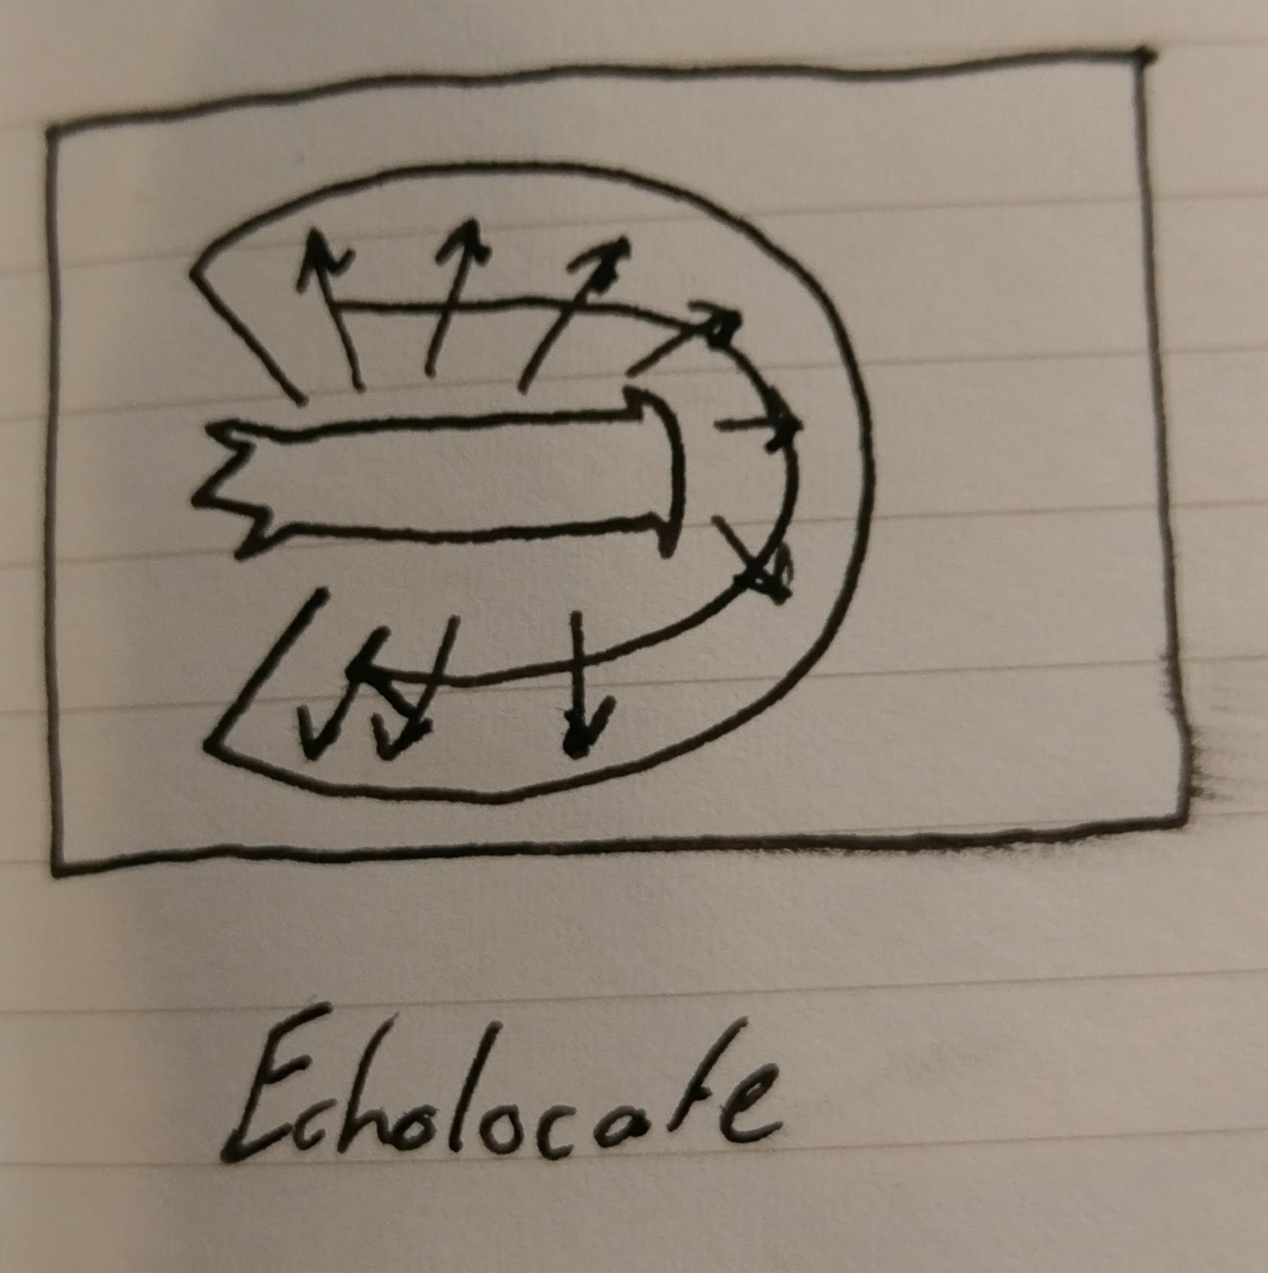
* New Attack(Replaces Grab): SideScreech: Like the basic attack but only emits from the sides. Slows down for 1s before using it. Not cascading
* 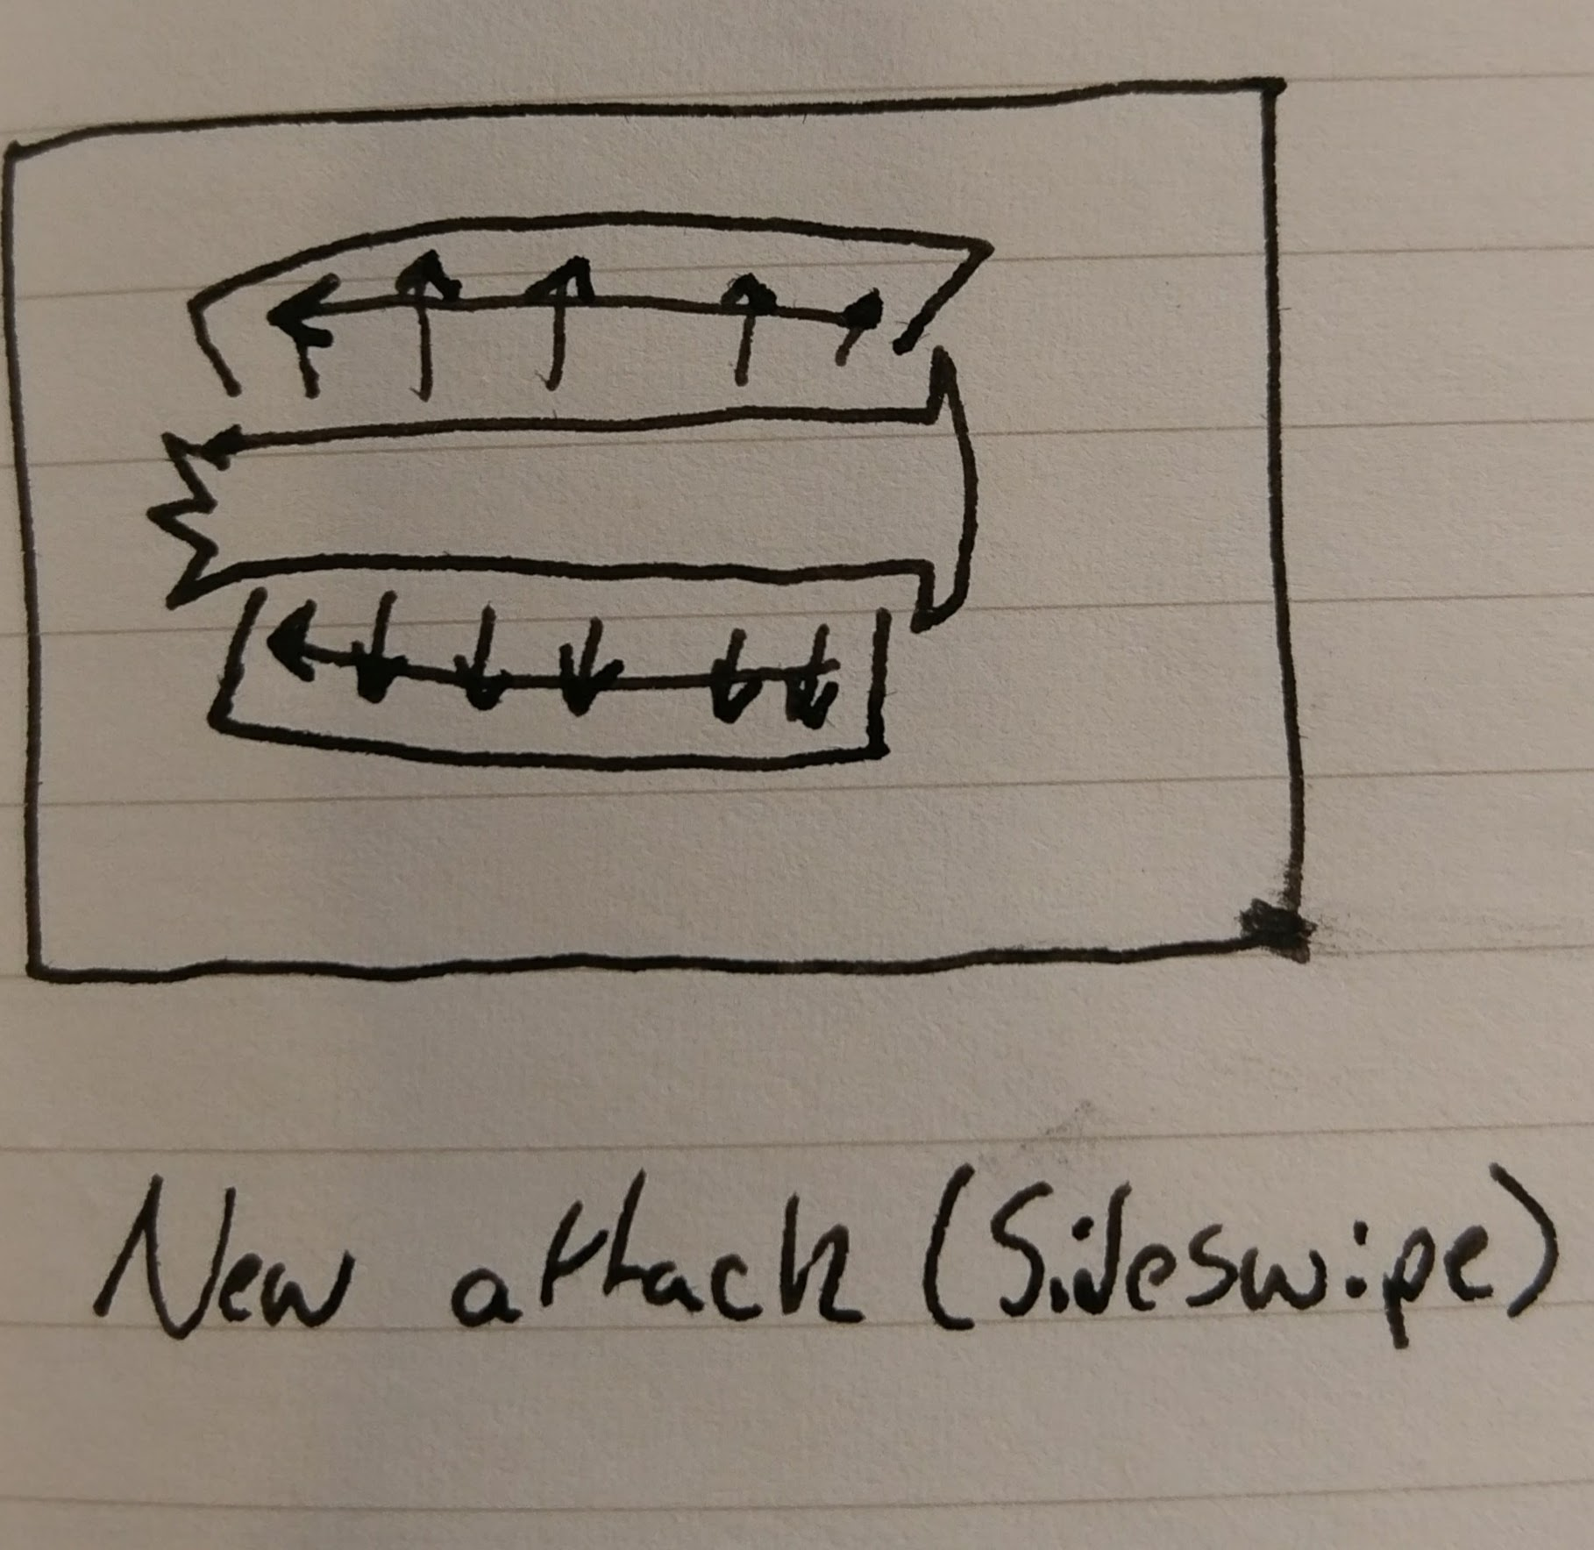
* Phase 2: Boss is faster: Uses rush attack more often.
* Boss room changes: Make it a big circle, with a massive pillar in the middle.

**Weapon:** Voice of Shuud

**Type**: Assault Rifle

**Bullet Type:** Laser

**Magazine size:** Moderate (30)

**Damage:** High

**Rate of Fire:** VERYFast

**Reload:** Slowish

**Effect:** Plays her Scream as you fire. Very accurate.

**Lyra, Heart of the Sword**

* Phase 1: Minions spawn after four laser attack instead of before
* Boss room changes: Make the room bigger